

Created : 2015/16
Ratified By Governors: 11/2017 Review Date: 11/2019

Created : 2016/17
Ratified By Governors: 11/2017 Review Date: 11/2018

Created : Signed:
Ratified By Governors: Review Date:

Created : Signed:
Ratified By Governors: Review Date:

Created : Signed:
Ratified By Governors: Review Date:

Created : Signed:
Ratified By Governors: Review Date:

Created : Signed:
Ratified By Governors: Review Date:

Created : Signed:
Ratified By Governors: Review Date:

Created : Signed:
Ratified By Governors: Review Date:

Created : 2016/17
Ratified By Governors: 11/2017 Review Date: 11/2018

CHILD PROTECTION /
SAFEGUARDING POLICY 2024-25

Approved by the Board of Governors: February 2023

Policy review date: February 2025

Updated following guidance from Department of Education ‘Safeguarding and Child
Protection in Schools: A Guide for Schools’(Updated September 2022)

Introduction
Created : Signed:
Ratified By Governors: Review Date:

Created : 2015/16
Ratified By Governors: 11/2017 Review Date: 11/2019

CONTENT

1. Carhill IPS Safeguarding ethos
2. United Nations Convention on the Rights of the Child
3. Safeguarding principles
4. Policy Aims
5. Carhill IPS Safeguarding Team and Contact Information
6. What is child abuse?
7. Types of child abuse
8. Specific types of abuse
9. Preventative Curriculum
10. Protection procedures: The role of staff
11. Safeguarding and Child Protection concerns – Raising and responding to concerns
12. Role of Social Services
13. Confidentiality
14. Training
15. Staff recruitment
16. Operation Encompass
17. Links and Support
18. Further Information

Appendix 1 Diagram of Procedures for Reporting a Child Protection /Safeguarding
Appendix 2 Policy Statement
Appendix 3 Staff Register
Appendix 4 Criminal Records
Appendix 5 Annual Child Protection/Safeguarding Training for all staff/Governors
Appendix 6 Summary of Policy Procedures Published annually to Parents
Appendix 7 Circular List
Appendix 8 Substitute Teacher and Visitor Guidelines
Appendix 9 Note of Concern Template
Appendix 10 Operation Encompass
Carhill IPS School Motto
‘Learning Together, Growing Together’

Carhill IPS Mission Statement
‘We believe in empowering our children to respect others and their differences as each person is uniquely special.
At the heart of Carhill is a nurturing family environment and through genuine care, we promote positive moral values in addition to providing diverse, inspiring and challenging curriculum experiences.
The staff team at Carhill equip every child with the skills to become a life-long learner and strive to achieve success in everything they do.’

1. CARHILL IPS SAFEGUARDING ETHOS

‘The curriculum needs to be delivered in a school with an ethos which empowers children; a school which allows them to voice ideas, feelings and make a contribution to the educational process.’

1.1 All staff in Carhill Integrated Primary School have a responsibility for the Pastoral Care, general welfare and safety of the children in our care and we will carry out this duty by providing a caring, supportive and safe environment, where each child is valued for his or her unique talents and abilities, and in which all our young people can learn and develop to their full potential. All staff, teaching and non-teaching are alerted to the signs of possible abuse and know the procedures to be followed. This Policy sets out guidance on the action, which is required where abuse or neglect of a child is suspected and outlines referral procedures within our school.

1.2 The governors and staff of Carhill Integrated Primary School fully recognise the contribution it makes to safeguarding children. We recognise that all staff, including volunteers, have a full and active part in protecting our pupils from harm.

‘All staff in a school, both teaching and non-teaching, have responsibility to ensure the protection and welfare of children is paramount. This also extends to all volunteers accepted to work in the school during school hours when pupils are on the premises.’
(Safeguarding in schools: A guide for schools, Dept. of Education, Sept 2019).

1.3 This policy is informed by the guidance and procedures set out by Safeguarding in schools: A guide for schools, Dept. of Education, Sept 2019, and the Area Child Protection Committees’ (ACPC) Regional Policy and Procedures (2005).

The Children (Northern Ireland) Order 1995 states that ‘the welfare of the child must be the paramount consideration’ in all decisions concerning the child.

This is also reflected in Article 3 of the UN Convention on the Rights of the Child – ‘the best interests of the child shall be of primary consideration’. At Carhill IPS we strive to maintain an environment where all members of the school community feel secure and valued.

1.4 Our policy applies to all staff, governors and volunteers working
in the school. The purpose of the procedures set out in this policy is
to safeguard and protect our pupils by ensuring that every adult who
works in our school – teachers, non-teaching
staff and volunteers – has clear guidance on the action which is
required where abuse or neglect of a child is suspected. The issue
of child abuse will not be ignored by anyone who works in our school, and we know that some forms of child abuse are also a criminal offence.

1.5 The governors of Carhill IPS have adopted the following Child Protection / Safeguarding Policy which will be reviewed on an annual basis.

2. THE UNITED NATIONS CONVENTION ON THE RIGHTS OF THE CHILD (1991)

2.1 This sets out the rights that all children and young people up to the age of 18 should have. We are fully aware of those ‘Articles’ from the United Nations Convention on the Rights of the Child which are most relevant to the ‘Safeguarding’ of our pupils.

2.2 Article 3 (Best Interests of the Child): The best interests of the child must be a primary consideration for all actions concerning children taken by public or private social welfare institutions, courts of law, administrative authorities or legislative bodies. This includes ensuring the child is given the protection and care necessary for their wellbeing, taking into account the rights and duties of others towards them. Organisations, services and facilities responsible for the care or protection of children must conform with appropriately set standards.

2.3 Article 12 (Voice of the Child): A child who is capable of forming his or her own views has the right to express those views freely in all matters which affect them, those views being given due weight in accordance with their age and maturity. This is particularly the case for any judicial and administrative proceedings affecting them. A child can either give their views directly, or have their views represented appropriately on their behalf.

2.4 Article 19 (Protection from all forms of violence): Governments should ensure that children are properly cared for and their right to be protected from harm and mistreatment is upheld.

2.5 Article 20 (Children deprived of family environment):Children who cannot be looked after by their own family have a right to be looked after properly by people who respect their ethnic group, religion, culture and language.

2.6 Articles 34 and 36 (Exploitation): Governments should protect children from all forms of exploitation.

2.7 Article 39 (Rehabilitation of child victims): Children who have been harmed should receive help to recover and reintegrate into society.

3. SAFEGUARDING PRINCIPLES

3.1 Our core safeguarding principles are:
- The school’s responsibility to safeguard and promote the welfare of children is of paramount importance.
- The voice of the child should be heard.
- Parents are supported to exercise parental responsibility and families helped to stay together.
- We work in partnership with families, agencies, individuals and professionals.
- Safer children make more successful learners.
- Preventing problems is key.
- Representatives of the whole-school community of pupils, parents, staff and our board of governors will be involved in policy development and review.
- Policies will be reviewed at least annually unless an incident or new legislation or guidance suggests the need for an interim review.
3.2 There are two elements to our role of safeguarding and promotion of the welfare of children.
These are:
• arrangements to take all reasonable measures to ensure that risks of harm to children’s welfare are minimised; and
• arrangements to take all appropriate actions to address concerns about the welfare of a child, or children, working to agreed local policies and procedures in full partnership with other local agencies.
(Safeguarding Children in Education Sept 2004, DfES/0027/2004)

3.3 This policy will be reviewed and updated annually, particularly taking consideration of new guidance / circulars from DE.

3.4 This policy is available on the school website and is included in the staff handbook and volunteers’ handbook.

4. POLICY AIMS

4.1 It is the policy of Carhill IPS, to protect the children in our care from
harm and to ensure their continuing safety in the following ways:

• by maintaining written procedures discussed and agreed by the Board of Governors which will be followed if the school is alerted to possible abuse;
• by making the teaching and non-teaching staff aware of the school’s safeguarding procedures and also the signs of possible abuse;
• by designating a teacher and a deputy teacher for Child Protection responsibilities who will be known to all staff and pupils
Designated Teacher (D.T.) – Mr C. McGilligan
Deputy Designated Teacher (D.D.T.) – Mr A. Steen
• by setting up a Safeguarding Team made up of the Principal, Designated Teacher, Deputy Designated Teacher and two governors to oversee child protection procedures in the school;
• by continually reviewing and monitoring the system for recording information (CPOMS) about any action taken in cases of suspected or alleged abuse. All safeguarding incidents are recorded and managed in CPOMS (Child Protection Online Management System), a safeguarding and child protection management system for schools
• by providing an environment within the school and classroom in which every child is valued, leading to the development of their self-esteem;
• by allowing a variety of opportunities for class and group discussion of thoughts and feelings in an atmosphere of trust, acceptance and tolerance;
• by integrating the key concepts of safeguarding with the existing curriculum and by developing awareness and skills for personal safety and encouraging confidence to make good decisions;
• by monitoring children’s welfare and physical, emotional, social, intellectual and behavioural development;
• by informing parents of the schools Child Protection / Safeguarding Policy;
• and, by continuing contact with appropriate agencies in order to promote co-operation to protect children.

4.2 The safety and welfare of the children is always of paramount importance to all staff. We have a duty to ensure that all children in our care are not put at risk during activities.

4.3 Within the school day it is the duty of all staff to ensure:
1.That all learning activities, including school trips, are organised and supervised to the highest standards.
2.That the appropriate ratio of adults to children is applied, dependant of the age of the children.
3.That the school building is adequately heated, and ventilated.

4.4 A child may suffer or be at risk of suffering from one or more types of abuse and abuse may take place on a single occasion or may occur repeatedly over time.

5. THE SAFEGUARDING TEAM AT CARHILL IPS

5.1 The safeguarding team consists of:
Chairperson of the Board of Governors -
Designated Governor for Child Protection –
The designated teacher (DT) for Child Protection is Mr Ciaran McGilligan
Contact details: email: cmcgilligan295@c2kni.net Tel: 028 295 58635

The deputy designated teacher is Mr Alan Steen
Contact details: email: asteen162@c2kni.net Tel: 028 295 58635

The Principal is Mrs Samantha Russell
Contact details: email: srussell675@c2kni.net Tel: 028 295 58635

5.2 CHILD PROTECTION POLICY
‘Children have the right to be protected from all forms of violence; they must be given proper care by those looking after them.’
(Article 19 of U.N. Convention on the Rights of the Child, agreed by the UK in 1991)

5.3 THE CHILDREN ORDER (NORTHERN IRELAND) 1995
The Children Order (Northern Ireland) is the principal statute governing the care, upbringing and protection of children in Northern Ireland. It addresses several areas of concern relating to children and their families including:
- Promoting children’s welfare, by keeping them informed about the decisions that are made about their lives;
- Promoting a new model of parenthood based on children’s needs for the care their parents can provide even after family breakdown;
- Protecting children from harm, by ensuring that concerns about their safety are properly investigated and that intervention (where necessary) is conducted decisively;
- And, Improvement in the standards and efficiency of services provided to children and their families primarily through the establishment of a multi-disciplinary and inter-agency approach based on Area Child Protection Committee.

5.4 The staff members of Carhill Integrated Primary School have a primary responsibility for the care, welfare and safety of our pupils. We will make a determined effort to protect them from abuse and to minimise the risk of abuse through our Pastoral Care Policy which aims to provide a caring and safe environment in which the children can learn and develop their abilities.

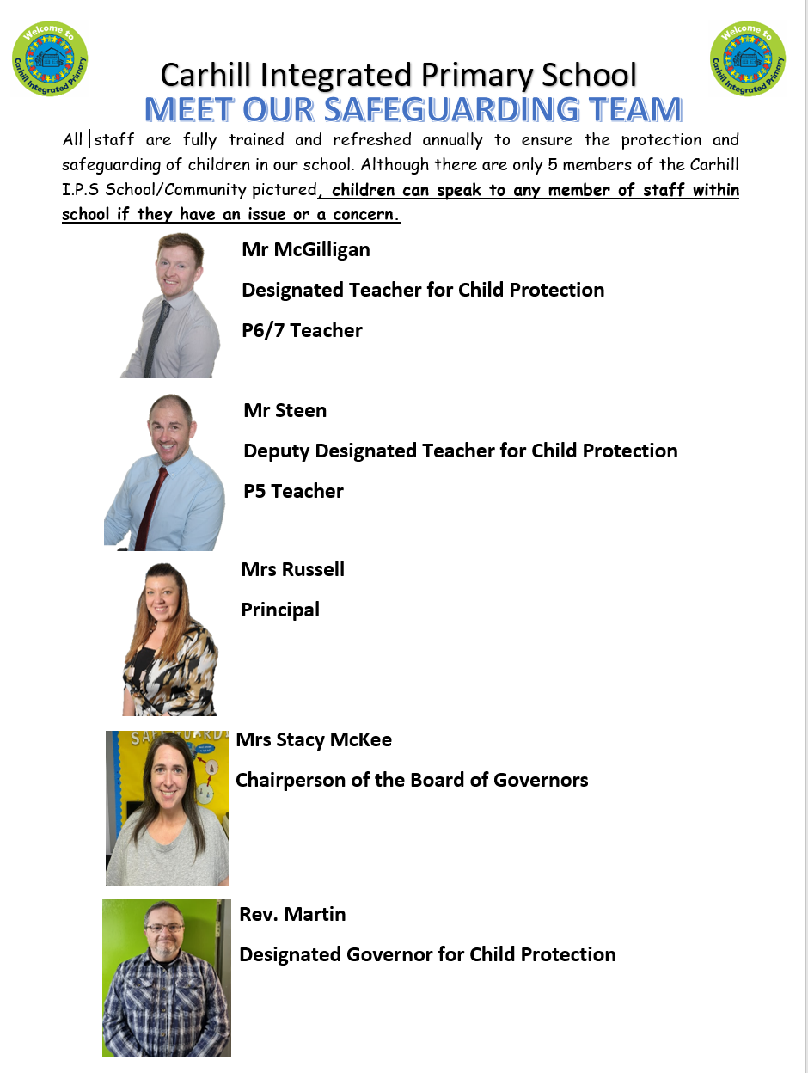

6. WHAT IS CHILD ABUSE?

6.1 (A child is a person under the age of 18 years as defined in the Children
Order NI 1995)

6.2 Child Abuse occurs when ‘a child is neglected, harmed or not provided with proper care. Children may be abused in many settings, in a family, in an institutional or community setting, by those known to them, or more rarely by a stranger.’ (ACPC, 2005)

6.3 Child abuse occurs in families from all social classes and cultures, and it also occurs in agencies and organisations. Abusers come from all walks of life and all occupations and professions. Child abuse can manifest in a number of ways and can involve a combination of the forms of abuse.

6.4 Children may be abused by a parent, a sibling or other relative, a carer (i.e. a person who has actual custody of a child such as a foster parent or staff member in a residential home), an acquaintance or a stranger, who may be an adult or a young person. The abuse may be the result of a deliberate act or of a failure on the part of a parent or carer to act or to provide proper care or both. The abuse may take a number of forms.

7. TYPES OF ABUSE

The following definitions are from Co-operating to Safeguard Children and Young People in Northern Ireland (2017).

7.1 Staff at Carhill IPS undergo training which is provided annually to ensure that they are fully aware of the types of abuse and of the signs and symptoms of abuse. Training for all staff last took place in August 2021. Staff members are made aware of the possible implications of, and alert to, all such signs, particularly if they appear in combination or are repeated regularly.

7.2 Attendance, absence and exclusions can all be indicators of abuse and as such these will be closely monitored by the Designated Teacher/School Principal.
(See Carhill IPS, Attendance Policy)

7.3 NEGLECT
Neglect is the failure to provide for a child’s basic needs, whether it be adequate food, clothing, hygiene, supervision or shelter that is likely to result in the serious impairment of a child’s health or development. Children who are neglected often also suffer from other types of abuse.
Possible signs or symptoms of neglect include:
- Poor hygiene
- Constant hunger/cramming food
- Inadequate / inappropriate clothing
- Constant tiredness
- Exposed to danger/lack of adequate supervision
- Untreated illness
- Lack of peer relationships
- Compulsive stealing/begging

7.4 PHYSICAL ABUSE
Physical Abuse is deliberately physically hurting a child. It might take a variety of different forms, including hitting, biting, pinching, shaking, throwing, poisoning, burning or scalding, drowning or suffocating a child.
Possible signs or symptoms of physical abuse include:
- Unexplained bruises (in places difficult to mark)
- Human bite marks, welts or bald spots
- Unexplained lacerations, fractions or abrasions
- Untreated injuries
- Self-destructive tendencies
- Chronic runaway
- Fear of going home

7.5 SEXUAL ABUSE
Sexual Abuse occurs when others use and exploit children sexually for their own gratification or gain or the gratification of others. Sexual abuse may involve physical contact, including assault by penetration (for example, rape, or oral sex) or non-penetrative acts such as masturbation, kissing, rubbing and touching outside clothing. It may include non-contact activities, such as involving children in the production of sexual images, forcing children to look at sexual images or watch sexual activities, encouraging children to behave in sexually inappropriate ways or grooming a child in preparation for abuse (including via e-technology). Sexual abuse is not solely perpetrated by adult males. Women can commit acts of sexual abuse, as can other children.
Possible signs or symptoms of sexual abuse include:
- Bruised or sore genitals
- Genital infection
- Signs of mutilation
- Difficulty in walking or sitting
- Inappropriate sexual language or behaviour
- Low self-esteem
- Chronic depression
- Substance abuse
- Personality changes
- Fear of going home

7.6 EMOTIONAL ABUSE
Emotional Abuse is the persistent emotional maltreatment of a child. It is also sometimes called psychological abuse and it can have severe and persistent adverse effects on a child’s emotional development.
Emotional abuse may involve deliberately telling a child that they are worthless, or unloved and inadequate. It may include not giving a child opportunity to express their views, deliberately silencing them, or ‘making fun’ of what they say or how they communicate. Emotional abuse may involve bullying - including online bullying through social networks, online games or mobile phones - by a child’s peers.
Possible signs or symptoms of emotional abuse include:
- Bullying of others
- Change in personality from outgoing to withdrawn
- Difficulty in forming/maintaining relationships with others
- Depression
- Signs of mutilation
- Attention seeking
- Chronic runaway
- Wetting and soiling
- Sudden speech disorders
- Low self-esteem

7.7 EXPLOITATION
Exploitation is the intentional ill-treatment, manipulation or abuse of power and control over a child or young person; to take selfish or unfair advantage of a child or young person or situation, for personal gain. It may manifest itself in many forms such as child labour, slavery, servitude, engagement in criminal activity, begging, benefit or other financial fraud or child trafficking. It extends to the recruitment, transportation, transfer, harbouring or receipt of children for the purpose of exploitation. Exploitation can be sexual in nature.
8. SPECIFIC TYPES OF ABUSE

8.1 Grooming
(See Carhill IPS, Online Safety Policy)
Grooming of a child or young person is always abusive and/or exploitative. It often involves perpetrator(s) gaining the trust of the child or young person or, in some cases, the trust of the family, friends or community, and/or making an emotional connection with the victim in order to facilitate abuse before the abuse begins. This may involve providing money, gifts, drugs and/or alcohol or more basic needs such as food, accommodation or clothing to develop the child’s/young person’s loyalty to and dependence upon the person(s) doing the grooming. The person(s) carrying out the abuse may differ from those involved in grooming which led to it, although this is not always the case.

8.2 Grooming is often associated with Child Sexual Exploitation (CSE), but can be a precursor to other forms of abuse. Grooming may occur face to face, online and/or through social media, the latter making it more difficult to detect and identify.

8.3 Child Sexual Exploitation (CSE)
CSE is a form of sexual abuse where children are sexually exploited for money, power or status. It can involve violent, humiliating and degrading sexual assaults. In some cases, young people are persuaded or forced into exchanging sexual activity for money, drugs, gifts, affection or status. Consent cannot be given, even where a child may believe they are voluntarily engaging in sexual activity with the person who is exploiting them. CSE does not always involve physical contact and can happen online.

8.4 CSE can be perpetrated by adults or by young people’s peers, on an individual or group basis, or a combination of both, and can be perpetrated by females as well as males. While children in care are known to experience disproportionate risk of CSE, the majority of CSE victims are living at home. Potential indicators of CSE:
- Acquisition of money, clothes, mobile phones etc without plausible explanation.
- Truanting/leaving school without permission.
- Persistently going missing or returning late.
- Receiving lots of texts/ phone calls prior to leaving.
- Change in mood - agitated/stressed.
- Appearing distraught/dishevelled or under the influence of substances.
- Inappropriate sexual behaviour for age.
- Physical symptoms e.g., bruising, bite marks, etc.
- Collected from school by unknown adults or taxis.
- New peer groups.
- Significantly older boyfriend or girlfriend.
- Increasing secretiveness around behaviours.
- Low self-esteem.
- Change in personal hygiene (greater attention or less).
- Self-harm and other expressions of despair.
- Evidence or suspicion of substance abuse.

8.5 Carhill IPS recognises that while these indicators can be useful in
identifying potential risk, their presence does not necessarily mean

CSE is occurring. More importantly, nor does their absence mean it is
not.

8.6 CSE is a form of child abuse and, as such, any member of staff suspecting that CSE is occurring should follow the school child protection policy and procedures, including reporting to the appropriate agencies.

8.7 The HSCT and PSNI should be involved as early as possible to ensure any evidence that may assist prosecution is not lost and to enable a disruption plan to reduce the victim’s contact with the perpetrator(s) and reduce the perpetrator(s) control over the victim to be put in place without delay.

8.8 Bullying
Bullying, including cyber-bullying, is a highly distressing and damaging form of abuse and is not tolerated in Carhill IPS. (See Carhill IPS, Anti-Bullying Policy)

8.9 All staff are vigilant at all times to the possibility of bullying occurring and will take immediate steps to stop it happening to protect and reassure the victim and to discipline the bully. Parents of both the bully and the victim will be personally contacted when bullying has been identified.

8.10 Any complaints by a parent that their child is, or may be, being bullied will be fully investigated by a member of the Safe-guarding team and action will be taken to protect the victim. This will usually include ensuring that another child or a group of small children befriends and supports the child being bullied during the school day. A parent making a complaint about bullying will have a personal response from the school within one week of making the complaint, indicating the investigation which has been carried out and the action taken.

8.11 The sanctions taken against a pupil who bullies will depend on the seriousness of the case but will include the loss of privileges in the school. His/her behaviour will be carefully monitored until members of staff are satisfied that the problem has stopped. If a pupil’s bullying behaviour persists, the second stage will be to instigate the child protection procedures.

8.12 The addressing bullying in schools Act (NI) 2016 when enacted will place a statutory duty on the BOG of the school will ensure implementation of anti-bullying measures within the school. Records will be subsequently kept of all incidents of bullying behaviours or alleged bullying behaviours involving a registered pupil at the school that occur:
(a) on the premises of the school during the school day;
(b) while travelling to or from the school during the school term;
(c) while the pupil is in the lawful control or charge of a member of staff of the school; or
(d) while the pupil is receiving educational provision arranged on behalf of the school and provided elsewhere than on the premises of the school. (See Carhill IPS Anti-Bullying Policy).
8.13 Domestic And Sexual Violence and Abuse:
The Stopping Domestic and Sexual Violence and Abuse Strategy (2016) defines domestic and sexual violence and abuse as follows:-

Domestic Violence and Abuse:
‘threatening, controlling, coercive behaviour, violence or abuse (psychological, virtual, physical, verbal, sexual, financial or emotional) inflicted on anyone (irrespective of age, ethnicity, religion, gender, gender identity, sexual orientation or any form of disability) by a current or former intimate partner or family member.’
Sexual Violence and Abuse
‘any behaviour (physical, psychological, verbal, virtual/online) perceived to be of a sexual nature which is controlling, coercive, exploitative, harmful, or unwanted that is inflicted on anyone (irrespective of age, ethnicity, religion, gender, gender identity, sexual orientation or any form of disability).’
N.B. Coercive, exploitative and harmful behaviour includes taking advantage of an individual’s incapacity to give informed consent.

8.14 Female Genital Mutilation
Female Genital Mutilation (FGM) is a form of child abuse and violence against women and girls. FGM comprises all procedures that involve partial or total removal of the external female genitalia, or other injury to the female genital organs for non-medical reasons. The procedure is also referred to as ‘cutting’, ‘female circumcision’ and ‘initiation’. The practice is medically unnecessary, extremely painful and has serious health consequences, both at the time when the mutilation is carried out and in later life.

8.15 FGM is a complex issue with many men and women from practising communities considering it to be normal to protect their cultural identity. The procedure may be carried out when the girl is newborn, during childhood or adolescence, just before marriage or during the first pregnancy. However, the majority of cases are thought to take place between the ages of five and eight, putting children in this age bracket at highest risk.

8.16 Where there is a concern that a child or young person may be at immediate risk of FGM this should be reported to the PSNI without delay. Contact can be made direct to the Sexual Referral Unit (based within the Public Protection Unit) at 028 9025 9299. Where there is a concern that a child or young person may be at risk of FGM, referral should be made to the relevant HSCT Gateway Team.

8.17 The NSPCC has a FGM helpline. The helpline is open 24/7 and can be called if you’re worried a child is at risk of, or has had, FGM. The helpline is free and anonymous.
Phone: 0800 028 3550 Email: fgmhelp@nspcc.org.uk
Forced Marriage Unit (FMU) including travellers.
A Forced Marriage is a marriage conducted without the valid consent of one or both parties and where duress is a factor. Forced Marriage is a criminal offence in Northern Ireland, and where an agency, organisation or practitioner has knowledge or suspicion of a forced marriage in relation to a child or young person, they should contact the PSNI immediately.

CHILDREN WHO DISPLAY HARMFUL SEXUAL BEHAVIOUR
Healthy sexual behaviour will normally have no need for intervention; however, consideration will be required as to appropriateness within the school setting.
Problematic sexual behaviour requires some level of intervention, depending on the activity and level of concern.
Harmful sexual behaviour is any behaviour of a sexual nature that takes place when:
- There is no informed consent by the victim and/or
- The perpetrator uses threat (verbal, physical or emotional) to coerce, threaten or intimidate the victim

Harmful sexual behaviour can include:
- Using age inappropriate sexually explicit words and phrases.
- Inappropriate touching.
- Using sexual violence or threats.
- Sexual behaviour between children is also considered harmful if one of the children is much older - particularly if there is more than two years’ difference in age or if one of the children is pre-pubescent and the other is not.
- However, a younger child can abuse an older child, particularly if they have power over them - for example, if the older child is disabled.

Harmful sexual behaviour will always require intervention and a member of the Carhill IPS Safeguarding team will seek the support that is available from the CPSS in the evident of observed behaviours.
No list of types of abuse or symptoms can be exhaustive. They may give rise to concern but are not in themselves proof that abuse has occurred. Where a member of staff is concerned that abuse may have occurred, he or she must report this immediately to the designated teacher (Mr C. McGilligan) or in his absence the DDTs (Mr A. Steen) who has specific responsibility for Child Protection.

9 PREVENTATIVE CURRICULUM

9.1 The Preventative Curriculum is the proactive promotion of positive
emotional health and wellbeing of pupils within and across the broader school community. This is achieved by raising awareness of social, emotional, and health issues, developing the confidence, resiliencies and coping skills of pupils, and in offering early intervention when pupils are experiencing certain difficulties.

9.2 The statutory personal development (PD) curriculum requires schools to give specific attention to pupils’ emotional wellbeing, health and safety, relationships, and the development of a moral thinking and value system. The curriculum also offers a medium to explore sensitive issues with children and young people in an age-appropriate way which helps them to develop appropriate protective behaviours (See PDMU Policy).

9.3 Pupils in Carhill IPS are taught how to develop healthy relationships, and to make informed choices in their lives so that they can protect themselves.

9.4 In Carhill IPS the board of governors and the senior leadership team are strongly committed to developing positive relationships and a caring ethos across the whole school. The personal development curriculum and wellbeing of pupils has a high priority in the school development plan and ‘keeping safe messages’ are embedded throughout the school.

9.5 Relationships and Sexuality Education
In Carhill IPS RSE is covered within the ‘Personal Development and Mutual Understanding’ (PDMU) area of learning. The RSE programme delivered within Carhill IPS is based on the ethos of our school and is subject to consultation with parents and pupils.

9.6 While it is important that those at risk are identified and interventions are put in place, it is equally important that children and young people are provided with information and skills in building healthy behaviours and relationships. Children in Carhill IPS are provided with the opportunity to develop good mental health and emotional resilience to enable them to identify abuse and exercise prevention skills.

9.7 Staff at Carhill IPS who suspect that a pupil is a victim of domestic violence or sexual abuse will raise their concerns with Mr C. McGilligan (DT).

9.8 More information is available at: www.nidirect.gov.uk/domestic-violence.
A 24 hour domestic and sexual violence helpline on:
Phone: 0808 802 1414 (Freephone)
Email: 24hrsupport@dvhelpline.org
Text: ‘support’ to 077 9780 5839 inclusivity
Children/young people seeking advice should contact the Childline Free Helpline at 0800 1111.

10. ROLES AND RESPONSIBILITIES

10.1 The Carhill IPS Safeguarding Team ensure effective co-ordination and
co-operation between the key individuals responsible for safeguarding
throughout the school.

10.2 The EA CPSS provides child protection training in relation to the specific responsibilities of each member of the team.

10.3 The responsibilities of the team should include:
- The monitoring and periodic review of Safeguarding and Child Protection arrangements in the school.
- Support for Mr C. McGilligan the Designated Teacher in the exercise of his child protection responsibilities, including recognition of the administrative and emotional demands of the post.
- Ensuring attendance of Governors and staff at relevant training - including refresher training - in keeping with legislative and best practice requirements.
- Reviewing child protection/ safeguarding practices annually using the Education and Training Inspectorate (ETI) pro-forma entitled ‘Guidance for the evaluation of child protection/safeguarding’.

10.4 Board of Governors must ensure that:
- A Designated Governor for Child Protection is appointed.
- A Designated and Deputy Designated Teacher are appointed in their schools.
- They have a full understanding of the roles of the Designated and Deputy Designated Teachers for Child Protection.
- Safeguarding and child protection training is given to all staff and governors including refresher training.
- Relevant safeguarding information and guidance is disseminated to all staff and governors with the opportunity to discuss requirements and impact on roles and responsibilities.
- The school has a Child Protection Policy which is reviewed annually
- The school has an Anti-Bullying Policy which is reviewed at intervals of no more than four years and maintains a record of all incidents of bullying or alleged bullying. See the Addressing Bullying in Schools Act (NI) 2016.
- The school ensures that other safeguarding policies are reviewed at least every 3 years or as specified in relevant guidance.
- There is a code of conduct for all adults working in the school.
- All school staff and volunteers are recruited and vetted, in line with DE Circular 2012/19
- They receive a full annual report on all child protection matters (It is best practice that they receive a termly report of child protection activities). This report should include details of the preventative curriculum and any initiatives or awareness raising undertaken within the school, including training for staff.
- The school maintains the following child protection records in line with DE Circulars 2015/13 Dealing with Allegations of Abuse Against a Member of Staff and 2020/07 Child Protection: Record Keeping in Schools: Safeguarding and child protection concerns; disclosures of abuse; allegations against staff and actions taken to investigate and deal with outcomes; staff induction and training.

10.5 Chair of Board of Governors
The Chairperson of the Board of Governor, Stacy McKee plays a pivotal role in creating and maintaining the safeguarding ethos within the school environment.

10.6 In the event of a safeguarding and child protection complaint being made against the Principal, Mrs Russell, it is the Chairperson who must assume lead responsibility for managing the complaint/allegation in keeping with guidance issued by the Department, employing authorities, and the school’s own policies and procedures.

10.7 The Chairperson is responsible for ensuring child protection records are kept and for signing and dating the Record of Child Abuse Complaints annually, even if there have been no entries.

10.8 Designated Governor for Child Protection
The Designated Governor for Child Protection, Rev. Martin , will take the lead in safeguarding/child protection issues in order to be able to advise the governors on:
- The role of the designated teachers.
- The content of child protection policies.
- The content of a code of conduct for adults within the school.
- The content of the termly updates and full annual designated teachers report.
- Recruitment, selection, vetting and induction of staff.

10.9 School Principal The Principal, Mrs S. Russell, as the Secretary to the Board of Governors, will assist the Board of Governors to fulfil its safeguarding and child protection duties, keeping them informed of any changes to guidance, procedure or legislation relating to safeguarding and child protection, ensuring any circulars and guidance from the Department of Education is shared promptly, and termly inclusion of child protection activities on the
BoG meeting agenda. In addition, the Principal takes the lead in
managing child protection concerns relating to staff.

10.10 The Principal has delegated responsibility for establishing and managing the safeguarding and child protection systems within the school. This includes the appointment and management of suitable staff to the key roles of Designated and Deputy Designated Teacher posts and ensuring that new staff and volunteers have safeguarding and child protection awareness sessions as part of an induction programme.

10.11 The Principal will ensure that parents and pupils receive a copy, or summary, of the Child Protection Policy at intake and, at a minimum, every two years.

10.12 The designated teacher needs to know:
- In all cases where abuse is suspected or where an allegation has been made by a pupil or a third party that abuse has taken place, or where serious concerns exist about the welfare of a child, teachers and other members of staff should report the information to the Designated Teacher.
- The Designated Teacher should not speak to the parents.

- The Designated Teacher should immediately refer these cases to or consult with Social Services.

- Where physical or sexual abuse is suspected or alleged, refer the case to PSNI and notify the Principal.
- Contact with or referral to Social Services will not automatically trigger a Child protection investigation; however, it may result in an investigation whether or not the teacher intended a formal referral.
- Any allegation by a child that he or she is suffering or has suffered abuse should immediately trigger the reporting procedures.
- The Principal should be alerted immediately to a case and should be kept informed by the Designated Teacher.
- Where the Designated Teacher is suspected of abuse, the Principal should be informed immediately, and the normal reporting procedures should be investigated.
- Where the Principal is suspected of abuse, the Designated Teacher should report the matter to Social Services, the Police and the Chairperson of the Board of Governors.
- When making a referral, the Designated Teacher should be informed of the timing of the strategy discussion between the statutory agencies, which will decide whether and how to investigate. Clarify, when, how and by whom the parents and the child will be told that a referral has been made.
- The Designated Teacher or a teacher who knows the child well should be prepared to contribute the school's knowledge of the child to the discussion.

10.13 Deputy Designated Teacher for Child Protection
The role of the Deputy Designated Teacher, Mr A. Steen is to work co-operatively with Mr C. McGilligan, the Designated Teacher in fulfilling his responsibilities.

10.14 The Deputy Designated Teacher should develop sufficient knowledge and experience to undertake the duties of the Designated Teacher when required.

10.15 Other Members of School Staff
Members of staff must refer concerns or disclosures initially to the Designated Teacher for Child Protection or to the Deputy Designated Teacher if he is not available.

  - Class teachers and members of support staff should complete the Note of Concern (See Appendix 9) if there are safeguarding concerns such as: poor attendance and punctuality, poor presentation, changed or unusual behaviour including self-harm and suicidal thoughts, deterioration in educational progress, discussions with parents about concerns relating to their child, concerns about pupil abuse or serious bullying and concerns about home circumstances including disclosures of domestic abuse.

  - Staff should not give children a guarantee of total confidentiality regarding their disclosures, should not investigate nor should they ask leading questions

  - Parents
The primary responsibility for safeguarding and protection of children rests with parents who should feel confident about raising any concerns they have in relation to their child.

- Parents can play their part in safeguarding by informing the school.
- If the child has a medical condition or educational need.
- If there are any Court Orders relating to the safety or wellbeing of a parent or child.

- If there is any change in a child’s circumstances for example - change of address, change of contact details, change of name, change of parental responsibility.
- If there are any changes to arrangements about who brings their child to and from school.
- If their child is absent and should send in a note on the child’s return to school. This assures the school that the parent/carer knows about the absence. More information on parental responsibility can be found on the EA website at: www.eani.org.uk/schools/safeguarding-and-child-protection

It is essential that the school has up to date contact details for the parent/carer.

11 RESPONDING TO SAFEGUARDING AND CHILD PROTECTION CONCERNS
Safeguarding is more than child protection. Safeguarding begins with promotion and preventative activity which enables children and young people to grow up safely and securely in circumstances where their development and wellbeing is not adversely affected. It includes support to families and early intervention to meet the needs of children and continues through to child protection. Child protection refers specifically to the activity that is undertaken to protect individual children or young people who are suffering, or are likely to suffer significant harm.

School to customise the following two sections to reflect their procedures and staff involved but the process should be very similar to this: -

11.1 How a Parent Can Raise a Concern

In Carhill IPS we aim to work closely with parents/guardians in supporting all aspects of their child’s development and well-being. Any concerns a parent may have will be taken seriously and dealt with in a professional manner.

If a parent has a concern they can talk to the Class Teacher, the Designated or Deputy Designated Teacher for child protection or the Principal.

If they are still concerned they may talk to the Chair of the Board of Governors.
At any time, a parent may talk to a social worker in the local Gateway team or to the PSNI Central Referral Unit. Details of who to contact are shown in the flowchart in Appendix 6

11.2 Where School Has Concerns or Has Been Given Information about Possible
abuse by Someone Other Than a Member of Staff

In Carhill IPS, if a child makes a disclosure to a teacher or other member of staff which gives rise to concerns about possible abuse, or if a member of staff has concerns about a child, the member of staff will complete a Note of Concern (see Appendix 9) and act promptly. They will not investigate - this is a matter for Social Services - but will discuss these concerns with the Designated Teacher or with the Deputy Designated Teacher if he/she is not available.

The Designated Teacher will consult with the Principal or other relevant staff always taking care to avoid due delay. {If Principal is not available you need to indicate what will happen in your school} If required advice may be sought from the Education Authority Designated Officer for Child Protection. The Designated Teacher may also seek clarification from the child or young person, their parent/carer.

If a child protection referral is not required the school may consider other options including monitoring, signposting or referring to other support agencies e.g. Family Support Hub with parental consent and, where appropriate, with the child/young person’s consent.

If a child protection referral is required, the Designated Teacher will seek consent from the parent/carer and/or the child {if they are competent to give this} unless this would place the child at risk of significant harm.

The Designated Teacher will phone the Gateway team and/or the PSNI and will submit a completed UNOCINI referral form.

Where appropriate the source of the concern will be informed of the action taken.

For further detail please see Appendix 7

11.3 Where a Complaint Has Been Made about Possible Abuse by a Member of the School’s Staff or a Volunteer

When a complaint about possible child abuse is made against a member of staff the Principal (or the Designated Teacher if the Principal is not available) must be informed immediately. If the complaint is against the Principal, then the Designated Teacher should be informed and he will inform the Chairperson of the Board of Governors who will consider what action is required in consultation with the employing authority. The procedure as outlined in Appendix 1 will be followed.

12 ROLE OF SOCIAL SERVICES AND OTHER AGENCIES

12.1 Social Services have a statutory duty to investigate any case where they receive information suggesting that a child or young person may be in need of care, protection or control unless satisfied that such enquiries are unnecessary. Their objective is to ensure the safety and welfare of the child. They have a lead role in co-ordinating the work of all the agencies and professionals concerned with the child’s family. A joint protocol has been established between the Social Services and the Police Service NI for investigative purposes. This will involve the police in investigating situations where a crime may have been committed.

12.2 When there is suspicion that a child has been abused Social Services may convene a multi-disciplinary Case Conference which may involve the Designated Teacher, principal or a nominee depending upon who is best placed to contribute effectively to the discussion of the child’s welfare.

12.3 The objectives of the Case Conference are to:
- Share and exchange relevant information on a confidential basis;
- Determine the nature and degree of abuse or risk of abuse and whether to place the child’s name on the Child Protection Register;
- Devise a Child Protection plan which identifies the contribution that individual agencies and professionals will make;
- Identify a case co-ordinator (normally from the Social Services Department) and to arrange for the review of the plan on at least a six-month basis.
12.4 Reports for Child Protection Case Conferences: -
- should focus on child's educational progress and achievements,
attendance, behaviour, participation, relationships with other
children and adults within the school and where appropriate the child's appearance.
- if relevant, should include what is already known about the child's relations with his or her family and the family structure.
- Should be objective and based on evidence.
- should contain only fact, observations and reasons for concern.

12.5 Reports will be made available to the parents at the Child Protection Conference and may be used in court.

12.6 All reports to be checked and signed by the designated teacher or his deputy.
Decisions of Case Conferences will be forwarded to principals. If the child transfers to another school, the Social Services Co-ordinator should be informed, and the receiving school should be advised that the child’s name is on the Child Protection Register. All Child Protection records held by the school from which the child transfers should be destroyed, including case conference records, the receiving school should approach the Social Services directly for information. The school will however retain their own notes regarding child protection concerns.

12.7 Social Services will send information in writing to the school about any child whose name has been included on the Child Protection Register, including whether the child is in the care of Social Services and what information has been made known to the parents about allegations or suspicions of abuse. Social Services will ask the school authorities to pay particular attention to such children in respect of their attendance record, emotional and social development and any other cause for further concern. A social worker will liaise with the principal and/or other education staff about the child’s progress. When a child’s name is removed from the Child Protection Register schools will be informed in writing by Social Services. Records should be destroyed when the child’s name is removed from the Child Protection Register.

13 CONFIDENTIALITY

13.1 Staff should recognise that in order to protect people from harm, cases may arise where no promise of confidentiality can or should ever be made to a child or anyone else giving information about possible abuse.

13.2 Care should be taken so that information is only given to the appropriate person.

13.3 All staff should be aware of the confidential nature of personal information about a child or the child’s family.

13.4 Any disclosure by a pupil should be led by the pupil at her/his pace, without pressure for detail from the staff member.

13.5 If abuse is suspected, information should be given only to the strictly relevant people, such as the Principal or Designated Teacher.
13.6 Other staff members need only know enough to prepare them to act
with sensitivity to a distressed pupil. They do not need to know
details.

13.7 The staff member to whom the disclosure is made may need to decide on some person from whom they might need support. This can be done without divulging the pupil’s name or personal details.

13.8 A staff member who, through attending child protection meetings hears confidential information about family circumstances must respect confidentiality.

13.9 Particular care is necessary to maintain the confidentiality of such information, though there may be a need for the person attending to talk over his/her feelings about such disclosures with the Principal.

13.10 Staff members may pick up worrying information about children from parents, neighbours, or even other children. This should be passed on to the Principal or Designated Teacher and may be recorded in their “working notes”.

13.11 Any staff member who considers that a pupil has been or is at risk of abuse should talk to the pupil but not carry out an investigation. If the staff member is not satisfied with the answer or is refused an answer then the designated teacher should be advised of the situation.

14 TRAINING

14.1 All members of staff are obliged to undertake Child Protection training as part of their professional development. Such training will be updated annually.

14.2 AVOIDING ALLEGATIONS OF ABUSE
(Guidance for staff)

Staff members may unknowingly place themselves at risk of being accused of child abuse under the headings covered by the definition of child abuse. Such allegations are traumatic experiences which can involve investigations by school, employing authority and outside agencies and in cases lead to suspension of staff member. The following guidelines are offered as advice:

14.3 Staff Code of Conduct (see Staff Code of Conduct)
Private Meetings with Pupils
(a) Staff members should be aware of the dangers which may arise from private interviews with individual pupils. It is recognised that there will be occasions when confidential interviews must take place, but, where possible, such interviews should be conducted in a room with visual access, or with the door open, or in a room or area which is frequented by other people.

(b) Where such conditions cannot apply members are advised to ensure that another adult knows that the interview is taking place.

(c) Where possible another adult should be present or nearby during the interview.
Physical Contact with Pupils
(See Carhill IPS, Safe Handling and Intimate Care Policies)

(d) As a general principle staff members are advised not to make unnecessary physical contact with pupils. This is particularly the case with maturing children of primary school age.

(e) Physical contact which may be misconstrued by the pupil, parent or other casual observer should be avoided. Such contact can include well intentioned informal gestures such as putting a hand on the shoulder or arm, which if repeated with an individual pupil, could be misconstrued, as well as more obvious and more intimate contact which should never occur.

(f) There may be occasions when a distressed child needs comfort and re-assurance which may include physical comforting such as a caring parent would give. Members should use their discretion in such cases to ensure that what is, and what is seen by others present to be, normal and natural does not become unnecessary and unjustified contact, particularly with the same child over a period of time.

(g) Staff members are likely to come into physical contact with the children from time to time in the course of their work and should be aware of the limits within such contact should properly take place and of the possibility of such contact being misinterpreted by the child.

(h) If administering First Aid members should ensure wherever possible that other children or another adult are present if they are in any doubt as to whether necessary physical contact in the circumstances could be misconstrued.

(i) Following any incident where a member of staff feels that his/her actions have been, or may be, misconstrued a written report of the incident should be made immediately to the Principal or in his absence to the vice-principal. This would apply especially in a case where it has been necessary to restrain a child physically to prevent him/her from inflicting injury to others or self-injury.

(j) Staff should be particularly careful when supervising pupils on a residential visit where more informal relationships tend to be usual and where members may be in proximity to pupils in circumstances quite different from the normal school environment.
It would be impossible to lay down rules to cover all the circumstances in which staff members inter-relate with pupils and where opportunities for their conduct to be misconstrued might occur.

14.4 From time to time, however, it is wise for all staff to review their teaching styles / working practices, relationships with pupils and their manner and approach to individual pupils, to ensure that they give no grounds for doubt about their intentions, in the minds of colleagues, pupils or parents.
(See Carhill IPS, Educational Visits Policy)

15 STAFF RECRUITMENT MEASURES / VETTING PROCEDURES

15.1 At Carhill IPS, we comply with Statutory Child Protection Procedures
and ensure that the staff, volunteers, other agencies and adults working with the children exercise good practice and display common sense in all physical contact with children in their care.

15.2 Safeguarding in schools: A guide for schools, Dept. of Education, Sept 2019 states that, “all persons on school property are vetted, inducted and supervised as appropriate.”
Anyone working within the school may have the potential to abuse children. Therefore, procedures for screening staff (paid or voluntary) are embedded in the schools recruitment procedures. In following these procedures Governors and staff are doing their utmost to protect all children in their care from potential harm.

15.3 AccessNI Clearance
In accordance with DE Circular 2013/01 (updated September 2015) the following groups must have an Enhanced Disclosure Certificate (EDC) from AccessNI before taking up post in Carhill IPS:
- All new paid teaching and non-teaching staff.
- Examination Invigilators
- Private contracted transport providers - named drivers.

15.4 VOLUNTEERS
There are two types of volunteers working in schools: those who work unsupervised and those who work under supervision. Volunteers who work unsupervised are required to have an EDC. A volunteer who works under supervision is not required to obtain an EDC, however, the school will determine whether the level of supervision meets the statutory standard - see DE Circular 2012/19. This includes parental involvement.

15.5 Parental involvement is given high priority in the life of the school. We actively seek to work in partnership with parents. Parents are a valuable resource and can contribute greatly to the life of the school by sharing their time and talents.

15.6 The school will ensure that volunteers, eg coaches, music tutors, school photographers etc, who are employed by others, have the necessary clearances in place.

15.7 Visitors to Schools
Visitors to schools, such as parents, suppliers of goods and services, to carry out maintenance etc do not routinely need to be vetted before being allowed onto school premise. However, such visitors should be managed by school staff and their access to areas and movement within the school will be restricted as needs require.

15.8 Visitors will be:
- Met/directed by school staff/representatives.
- Signed in and out of the school by school staff.
- If appropriate, given restricted access to only specific areas of the school.
- Where possible, escorted by a member of staff/representative.
- Clearly identified with visitor passes.
- Access to pupils restricted to the purpose of their visit.

- If delivering goods or carrying out building/maintenance or repair tasks their work should be cordoned off from pupils for health and safety reasons.

15.9 Pupils on Work Experience
- Health and Social Care Programmes will require an Enhanced Disclosure Certificate for pupils on long term placement and may be required for pupils on work experience/ shadowing placements. The school will apply through its AccessNI Registered Body in advance. (See DE Circular 2013/01 for more information).
- Pupils coming into the school on work experience do not require AccessNI clearance if they are fully supervised by school staff. The normal child protection induction processes will apply in these circumstances. Our schools’ Child Protection leaflet will be provided and the person will sign in receipt of it being provided.

16. Operation Encompass

As of February 2023, we are involved with Operation Encompass. Operation Encompass is a nationwide scheme which all schools are involved with through close liaison with PSNI. Further information can be found at www.operationencompass.org and a version of the letter sent to all parents has been added to the Appendix.


17 USEFUL LINKS / SUPPORT AGENCIES

17.1 Advice and support are available from:

EA-NE Region Child Protection Team: 02894482223
Helpline available 9:00am – 4:30pm

EA-NE Child Protection Officer – Mrs Elaine Craig 02894482223
elaine.craig@neelb.org.uk

EA-NE Child Protection Officer – Mr Michael Kelly
michael.kelly@neelb.org.uk

Ea-NE Child Protection Officer – Ms Paula McCreesh
paula.mccreesh@neelb.org.uk

CPSSS Clerical Support Officer
anna.mitchell@neelb.org.uk

Single Point of Entry (SPOE) Gateway Referrals – Social Services
Tel: 03001234333 (Gateway Services)

Vetting and Barring Queries
Volunteers – Contact Claims and Legal Administration
Karen Mawhinney – 02825662310
Paid Staff – Human Resources – 02925662417

Children’s Law Centre (including legal concerns RE childhood mental health problems) – 08088085678

Adult Safeguarding – Care and Protection Teams – Northern Trust
Learning Disability 02827661391
Mental Health 02894413114
Older People 02825635511
Physical Disability/Sensory Impairment 02825635507

Useful contacts for practical support services to help improve mental health and emotional well-being within the Northern Trust area.
http://www.northerntrust.hscni.net/pdf/Mental Health useful contacts.pdf

Carecall: 08088000002 - (Staff counselling service) 38

17.2 Helpful Websites
www.familysupportni.gov.uk

www.nspcc.org.uk

www.addictionni.com

UNOCINI
(Understanding the needs of children in Northern Ireland)
www.dhsspsni.gov.uk/unocinini_forms.doc

Independent Safeguarding Authority
www.isa-gov.org.uk

Department of Education (Circulars)
www.deni.org.uk

Education and Training Inspectorate (ETI)
www.etini.gov.uk

PSNI Local child Abuse Enquiry Unit – 08456008000

PSNI Public Protection Units Ballymena 02890 650222 Ext 51211, 86167 or 86151

PSNI Care Unit (Coleraine) 028 70344122 or 08456008000

NSPCC 0800 800500

The School Nurse 028 27664101

EA-NE Welfare Officer 028 2565 3333

EA-NE Psychologist 028 70328462

Refer to policy on: Disposal of Records Schedule for Carhill IPS.

Appendix 1 PROCEDURES FOR REPORTING A CHILD PROTECTION/
SAFEGUARDING ISSUE

‘The first step in recognising abuse is the ability to entertain the possibility of abuse taking place.’ [S. Sgroi 1982]

There are a range of circumstances that would invoke Child Protection/ Safe-Guarding procedures.

Other sources of concern e.g. Social Services, etc.

A child makes a disclosure to a member of staff.


A member of staff has concerns about a child, either as a result of one observation, or many observations over a period of time.

A parent expresses concern about the safety of his /her child

In the case of suspected or disclosed child abuse the following will apply:-
Keep a written record of complaint at all stages
Member of staff does not investigate
But must act promptly

Designated Teacher informed
Matter discussed and notes taken

Designated Teacher meets with Principal to plan course of action and writes a record

Is a referral necessary, or do doubts remain?

Don’t know-consult Social Services/ EA
Tell complainant
Yes- refer to Social Services / Police and inform EA
No
Yes- discuss with Social Services/ Police how parent will be informed
Is parent the alleged abuser?
No – Tell parent
In addition to the above procedures, the Pastoral Care in School -Child
Protection/ Document gives guidelines to schools where a complaint

is made about possible abuse by a member of the school staff. When
addressing an allegation made towards a member of staff, the school will adhere to the procedures outlined in the DENI 2015/13 circular.
The relevant procedures, are recorded below.

The complaint is about possible abuse by a member of staff

Is it about someone other than the Principal or Designated Teacher?

Is it about the Designated Teacher?

Keep a written record at every stage, whether a referral is made or not

The Designated Teacher is the Principal

Is it about the Principal?

Tell the Designated Teacher –Mr McGilligan

Tell the Principal

Yes

No

Tell the Chairperson of the Board of Governors-

Tell the Principal

If a referral is necessary, or if doubts remain:

Consider precautionary suspension/ remove from direct contact duties
Seek advice from the EA Social Services

No- No further action
Tell subject of complaint, EA and complainant
Tell Social Services, PSNI, EA
Yes

Suspension to be done by Principal (where not the subject of complaint) or Chairperson of BOG

Seek advice from EA
No, but disciplinary
action
Instigate disciplinary proceedings

Tell complainant

Where the Designated Teacher is suspected to have abused a child, or such an allegation is made, the member of staff who is made aware of the possible offence should inform the Principal/ Lead Individual immediately, who will instigate the normal reporting procedures. Where the Principal is suspected, or an allegation is made against him/her, the matter should be reported to the Designated Teacher (where this is not the Principal), and he/she should report the matter immediately to Social Services (or, as the case may be, to the police), the Chairperson of the Board of Governors, and the Designated Officer of the Education Authority. Where the Principal is the Designated Teacher, the matter should be reported by the member of staff who is made aware of the possible offence, to Social Services (or, as the case may be, to the police), the Chairperson of the Board of Governors, and the Designated Officer of the EA.

APPENDIX 2: POLICY STATEMENT IN RELATION TO CHILD
PROTECTION / SAFE- GUARDING

The Board of Governors and staff of Carhill Integrated Primary School take a serious and professional approach to their responsibilities in relation to Child Protection/ Safe-Guarding.

‘Everyone who has contact directly or indirectly with children has a responsibility to promote their health and well-being and protect them from harm of all kinds. Children trust and depend on adults to safeguard them from harm, and those working with children have a responsibility to report any concerns about a child’s behaviour or concerns that abuse may have occurred.’
Northern Area Child Protection Committee Advice Document – 2003

Our Child Protection/ Safe-Guarding Policy seeks to guide and support staff in achieving this.

Section 1 What is Child Abuse?

Section 2: Overview, Rationale and Aims of Child Protection/ Safe-Guarding
As part of our pastoral care in Carhill Integrated Primary School we seek to support the child’s development in ways that will foster security, confidence and independence.

Section 3: Monitoring, Review and Evaluation of our Child Protection/ Safe-Guarding
Policy
The responsibility to ensure the monitoring, review and evaluation of the Child Protection/ Safe-
Guarding Policy rests with the Board of Governors, Principal and Designated Teacher.

Section 4: Key Roles and Responsibilities in Child Protection/ Safe-Guarding
Our policy seeks to ensure a consistent approach by all members of staff, to develop an effective partnership with parents, and to provide a clear statement to all how any incident would be addressed. Our policy identifies and defines the key roles that school staff, children, parents and governors have in delivering an effective Child Protection/ Safe-Guarding programme.

The Designated Teacher for Child Protection/ Safe-Guarding is Mr McGilligan

The Deputy Designated Teacher for Child Protection/ Safe-Guarding is Mr Steen

Section 5: Procedures for Reporting a Child Protection/ Safe-Guarding Issue
These guidelines relate specifically to incidents of suspected or disclosed child abuse, and are written in accordance with the Northern Area Child Protection Committee guidance and procedures. In all instances and aspects of provision, Carhill Integrated Primary School will act in accordance with guidance given by the Education Authority.

Copies of our complete Child Protection/ Safe-Guarding Policy are available on request from the Principal.

APPENDIX 3: STAFF REGISTER

All Staff are issued with the up-dated Staff Register annually in August.

APPENDIX 4: CRIMINAL RECORDS CHECK

From July 2010 the form “Standard/ Enhanced Disclosure ISA Registration”, supplied by Access Northern Ireland and the Independent Safeguarding Authority, is to be used. Since then there have been a few minor changes, primarily to the Principal’s part of the form.

The current form is available from the school office, along with guidance for parents/ volunteers.

APPENDIX 5: ANNUAL CHILD PROTECTION /SAFE-GUARDING
TRAINING FOR ALL STAFF / GOVERNORS

Child Protection/ Safe-Guarding Training, Aug 2024

- Staff were thanked for their endeavours last year in providing a safe, secure
environment for our children, and for their spirit of openness in sharing their
concerns with Mr McGilligan/Mrs Russell and adapting to the new recording system
within school.

- All staff were made aware of the signs of abuse and the procedures that should be followed.

- All governors will have child protection awareness training which will be updated annually.

- It is important that children and families are offered the support they need and very often small, practical steps or conversations with parents may be all that’s needed.

- We tend to err on the side of caution and the Child Protection/ Safe-
Guarding staff at the Board respond quickly and efficiently to any of our queries.

The Designated Teacher for Child Protection/ Safe-Guarding is Mr McGilligan and the
Deputy Designated Teacher is Mr Steen. As a strong line of communication has been developed over the year with social services and other professionals, Mr McGilligan is the first point of contact in most cases.
Therefore, there will be liaison between the Principal and Designated Teacher. Issues arising in school should be communicated to Mr McGilligan, in the first instance, and will be progressed appropriately.

A copy of the child protection/safeguarding policy was given to all members of staff, which can also be accessed in the public folder under child protection and available to all via our school website.

General Practice and Day to Day Procedures

All members of staff have received the appropriate flowchart of procedures relating to disclosures. A copy of these procedures are displayed within the staffroom. Because we care for the children if we have a concern which is rather sensitive, rather than worrying about it, we should communicate it to the Designated Teacher (Classroom Assistants may communicate the issue to the class teacher first where that is appropriate) Notes will be taken and kept in an Individual Class Record Book.

Any issues passed onto the designated teacher should then be kept confidential. It’s always useful to consider that if something was being reported about your child, you would not like it to be discussed. The Designated Teacher will decide what further action, if any, should be taken. This can range from monitoring the situation, to contacting a parent, to contacting a Social Worker.

Issues regarding confidentiality

- What happens when a child’s personal circumstances change?
All staff are requested to pass on any key information to Mr McGilligan that they may be given with regards to parental contact/ changes to home status etc, as this will be recorded in the child’s data capture form which are held in the office.

These sheets are renewed at the beginning of every year and the appropriate information is passed onto the next class teacher so he/she knows where there has been a problem. However, the details of the issue remain confidential and will only be given to the next teacher where the issue is on-going or has practical implications. If you have a child with ongoing child protection concerns or investigations, Mr McGilligan will speak to you during the baker days in August or at the earliest possible opportunity.

- When can information not be shared?
Confidential family/child issues should never be discussed in casual conversation anywhere in the school. The designated teacher for child protection is instructed by D.E.N.I. to withhold details if he/ she feels it is not necessary to divulge them.

In many cases, due to the course of events, the Principal is usually the first contact a parent or social worker will make. There will be cooperation between the principal and designated teacher.

- If a Social Worker phones to speak to a teacher The Office staff will be asked to give the message to Mr McGilligan. He may then consult with the child’s class teacher
before phoning back, and then report anything of a practical nature that needs to be
shared.

- No promise of confidentiality can or ever should be made to a child or anyone else giving information about possible abuse, although they can and should be reassured that information will be disclosed only to those professionals who need to know. If a child comes and says, ‘I want to tell you something that no one else should know’, or ‘I want you to keep a secret’: you, the teacher must tell the child, sensitively, that you cannot do so. You are here to help and listen and will try to do what you can. You must refer a case of abuse to the appropriate agency for the child’s sake. You can tell the child that the matter will only be disclosed to those that need to know about it.

No promise of confidentiality can or should ever be made to a child or anyone else giving information about possible abuse. Where a member of staff is concerned that abuse may have occurred, he or she must report immediately to the designated teacher.
Where teachers see signs that cause them concern, they should, as a first step, seek some clarification from the child with tact and understanding. Where a classroom assistant or another member of the school’s ancillary or auxiliary staff sees such signs, he or she should immediately bring them to the attention of either the class teacher or the designated teacher.

- Notes should be taken at the time, or as soon as possible after a
disclosure, and given to the Designated Teacher. While taking notes
the teacher or Staff Member should listen carefully, and be
careful not to ask leading questions. For example, staff should say, “Tell me what has happened”, rather than “Did they do X to you?”

- Always be sensitive to the situation. Care must be taken in asking, and interpreting children’s responses to questions about indications of abuse. The same considerations apply when a child makes an allegation of abuse, or volunteers information that amounts to this. In some cases, talking to the child will crystallise initial concerns into a suspicion that abuse has occurred, and point to the need for an immediate referral. Staff should therefore be aware that the way in which they talk to a child can have an effect on the evidence which is put forward, if there are subsequent criminal proceedings:

-Do not ask the child leading questions, as this can later be interpreted as putting ideas into the child’s mind;

-Do not ask questions which encourage the child to change his or her version of events in anyway, or which impose the adult’s own assumptions. For example, staff should say, “Tell me what has happened”, rather than, “Did they do X to you?”;

-The chief task at this stage is to listen to the child, and not to interrupt if he/she is freely recalling significant events, and to make notes of the discussion to pass on to the designated teacher. The notes should record the time, date, place and people who were present, as well as what was said. Signs of physical injury observed should be described in detail, or sketched, but under no circumstances should a child’s clothing be removed;

-Any comment by the child, or subsequently by a parent or carer or other adult, about how an injury occurred should be written down as soon as possible afterwards, preferably quoting words actually used;

-Do not give the child or young person undertakings of confidentiality, although they can, and should of course be, reassured that information will be disclosed only to those professionals
who need to know;

-Staff should also be aware that their notes of the discussion may need to be used in any subsequent court proceedings. While discreet preliminary clarification from the child or his parent or carer will often help to confirm or allay concerns. It is not the responsibility of teachers to carry out investigations into cases of suspected abuse.

Guidelines for self-protection

- As far as possible you should not touch children.
Obviously, with
very young children, if they have fallen or hurt themselves,
they may need to be helped up and given some reassurance.

- Never do something of a personal nature for children that they can do for
themselves. This includes cleaning bottoms etc, or any other activity that could be
misconstrued. Do not go into the toilet along with children, if possible.

- In the event of an incident where you have handled things inappropriately or where a
child has reacted in an unusual way, it is good to mention it to Mrs Russell as soon as possible, and certainly before you go home. At 2.50 pm Mrs Russell is, in general, in her office. If you finish work before that, speak to Mrs Russell. If she is unavailable, please leave a note. Where an issue is serious, feel free to knock the door and ask to speak to Mrs Russell or contact her immediately by telephone.

SITUATIONS ARE ALWAYS EASIER TO DEAL WITH WHERE NOTHING IS HIDDEN.

- It is wise, when speaking to a child individually, to use the Shared
Learning Area or to have another adult present.

- Occasionally, you may need to use reasonable force. Please be aware of recent DENI
Guidelines re: The Use of Reasonable Force which fall into three broad categories:

- Action may be necessary in self-defence or because there is an imminent risk of injury.
2. Action may be necessary if there is a developing risk of injury or significant damage to property.
3. Action may be necessary where a pupil is behaving in such a way that is compromising good order and discipline.
4. Children changing for P.E. / After School Activities should not change in front of the doorways but should move to the end of the room/classroom. This means that cleaners are not put in an awkward position.

APPENDIX 6: SUMMARY OF POLICY PROCEDURE PUBLISHED
ANNUALLY TO PARENTS
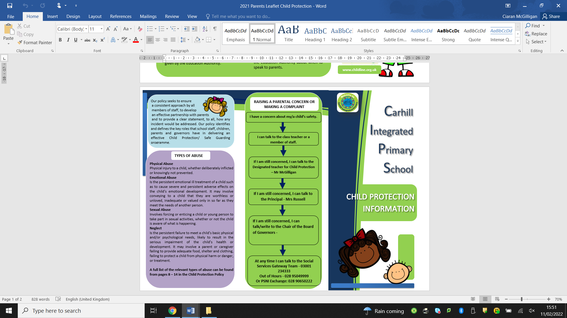

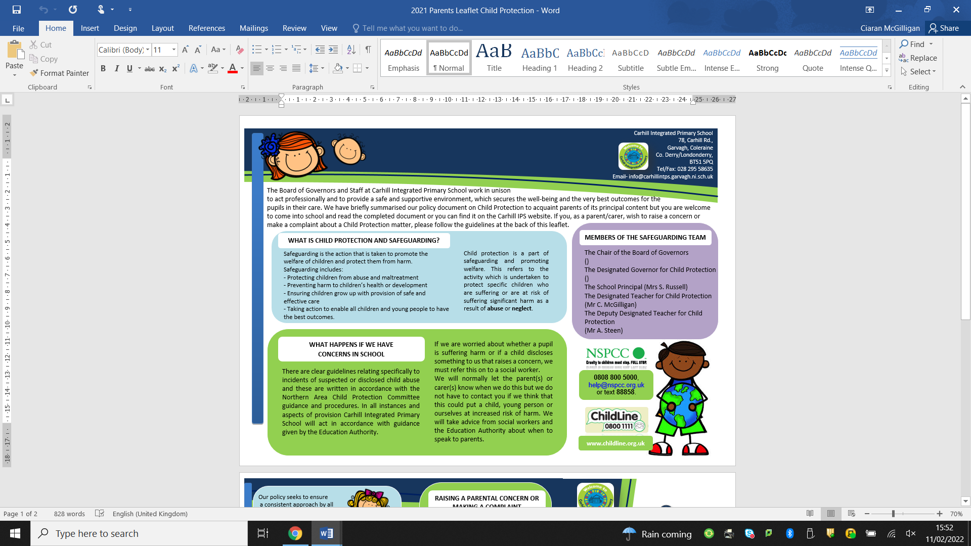

APPENDIX 7 : CHILD PROTECTION/SAFEGUARDING
Appendix 7: CIRCULAR LIST

Circular 1999/10 Pastoral Care in Schools
Provides advice and guidance to schools on their responsibilities in relation to child protection.

• Promotion of Positive Behaviour (2001)
Gives guidance and practical suggestions on a partnership approach to developing and maintaining good behaviour in school.

• Circulars 2006/6, 7, 8,9,25
These five circulars provide advice and guidance on the vetting of staff (including voluntary staff) and governors, the employment of substitute teachers and the recruitment and appointment of staff in schools.

• Circular 2007/01 Acceptable Use of the Internet and Digital Technologies in Schools
This circular draws attention to a range of guidance on the safe use of the internet and digital technologies in schools. It supersedes guidance issue in 1999 on the Policy for the Acceptable Use of the Internet in schools.

• Circular 2008/03 Pre-Employment Checking of Persons to Work in Schools – New Arrangements
From April 1 2008, responsibility for undertaking criminal history background checks transferred from PSNI Criminal Records Office to a new organisation called Access NI. This circular sets out the process which all grant-maintained schools must use to request pre-employment criminal history background checks on prospective employees, volunteers and school governors from that date.

• Circular 2008/10 Employment of Substitute Teachers
This circular advises that from 1 August 2008, substitute teachers employed by schools must be booked on-line, via the Northern Ireland Substitute Teachers Register.

• Circular 2010/01
Aims at; 1) making schools aware of guidance produced by the Equality Commission on Eliminating Sexual Orientation Discrimination in Northern Ireland. 2) making schools aware of the implications of the Sexual Offences (Northern Ireland) Order 2008, and 3) updating schools on work of ETI in evaluating delivery of Relationships and Sexuality Education in post-primary schools.

Department of Health, Social Services and Public Safety
• Co-Operating to Safeguard Children (2003)
This provides the updated guidance on child protection arising from the regulations of the Children (NI) Order 1995. It sets out how agencies should co-operate to promote children’s welfare and protect them from abuse and/or neglect.

• Area Child Protection Committees’ - Regional Policy and Procedures
(2005) and Amendments (2008)
Written to reflect the changes in thinking and practice contained in ‘Co-Operating to Safeguard’. This document sets out the procedures to be followed by all agencies working in the child protection environment.

• Circular 2013/13-Allegations against a Member of Staff- Procedures to follow

APPENDIX 8 : SUBSTITUTE TEACHER AND VISITOR GUIDELINES

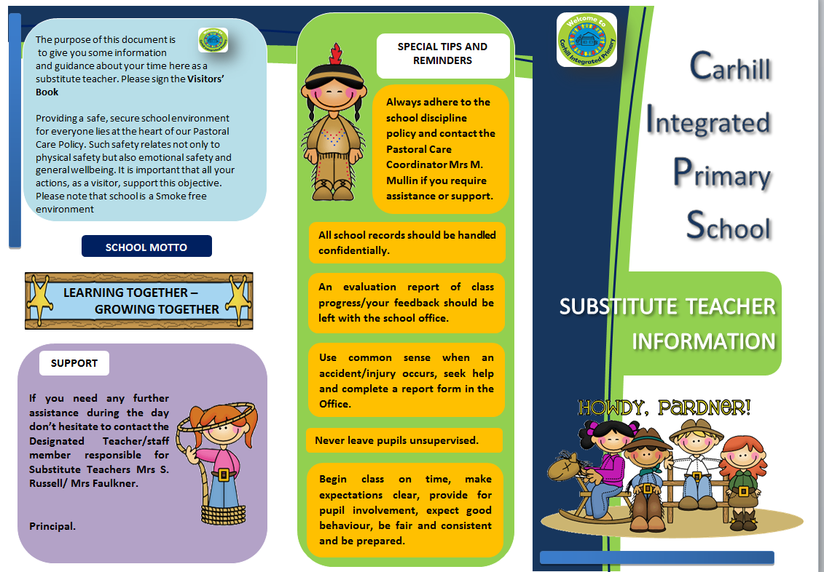
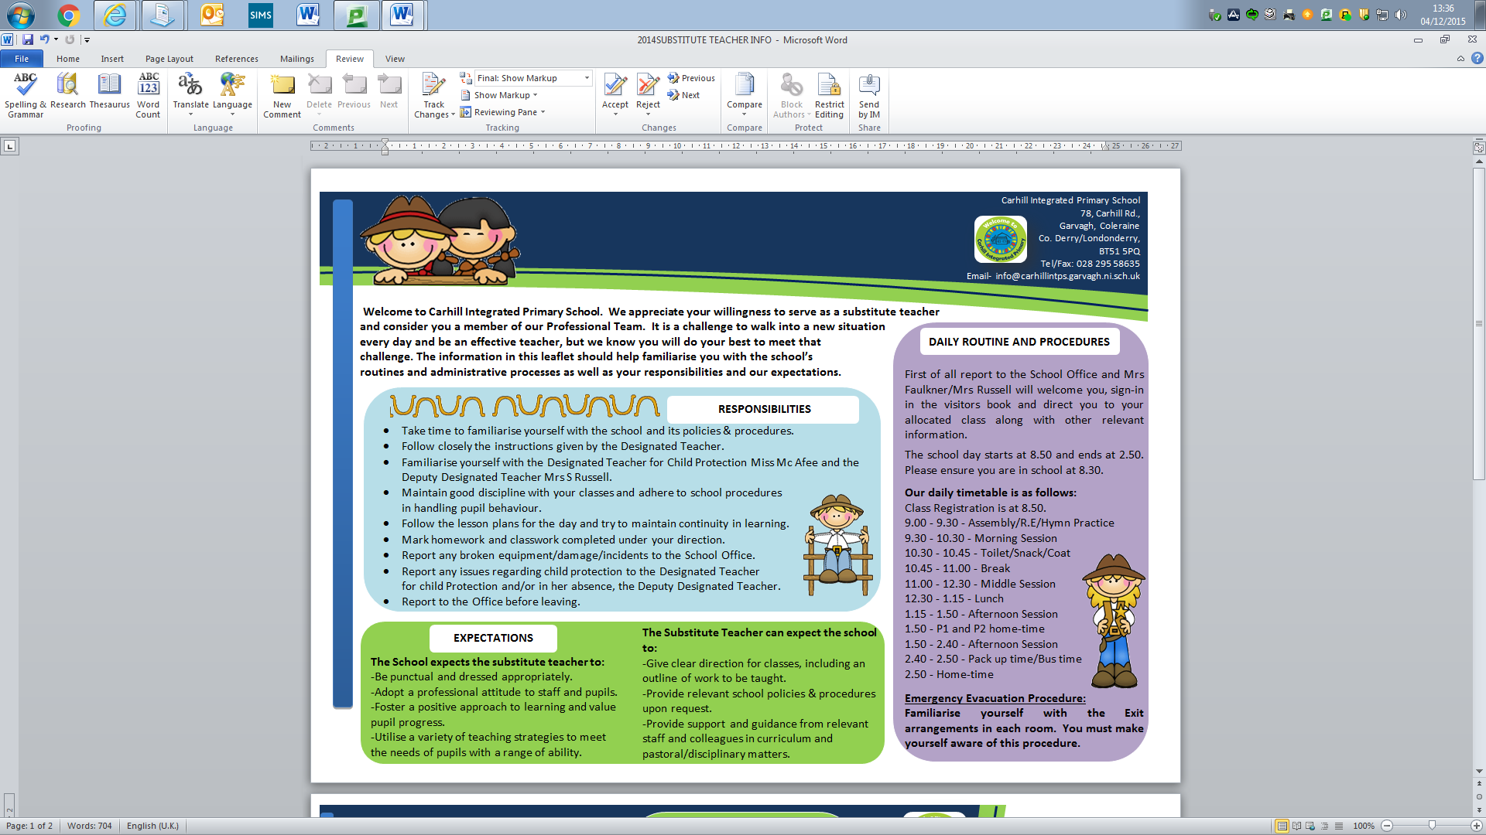

APPENDIX 9 : Note of Concern Template
CONFIDENTIAL

NOTE OF CONCERN - IF CPOMS IS NOT AVAILABLE
(e.g. for visitors/volunteers)

CHILD PROTECTION RECORD - REPORTS TO MR MCGILLIGAN

Name of Pupil:

Year Group:

Date, time of incident / disclosure:

Circumstances of incident / disclosure:

Nature and description of concern:

Parties involved, including any witnesses to an event and what was said or done and by whom:

Action taken at the time:

Details of any advice sought, from whom and when:

Any further action taken:

Written report passed to Designated Teacher: Yes: No:
If ‘No’ state reason:

Date and time of report to the Designated Teacher:

Written note from staff member placed on pupil’s Child Protection file
If ‘No’ state reason:
Yes: No:

Name of staff member making the report: ______________________________

Role of staff member making the report: ______________________________

Signature of Staff Member: __________________________ Date: __________

Signature of Designated Teacher: ____________________ Date: __________

Created : Signed:
Ratified By Governors: Review Date:

Created : Signed:
Ratified By Governors: Review Date:

Created : Signed:
Ratified By Governors: Review Date:

Created : Signed:
Ratified By Governors: Review Date:

Created : Signed:
Ratified By Governors: Review Date:

Created : Signed:
Ratified By Governors: Review Date:

Created : Signed:
Ratified By Governors: Review Date:

Created : Signed:
Ratified By Governors: Review Date:

Created : Signed:
Ratified By Governors: Review Date:

Created : Signed:
Ratified By Governors: Review Date:

Created : Signed:
Ratified By Governors: Review Date:

Created : Signed:
Ratified By Governors: Review Date:

Created : Signed:
Ratified By Governors: Review Date:

Created : Signed:
Ratified By Governors: Review Date:




Dear Parent/Carer,

I am writing to update you about our school’s participation in Operation Encompass. Operation Encompass is an early intervention partnership between Police and Schools. It is aimed at supporting children who are victims of domestic violence.

Operation Encompass is already established across all of England and Wales and is now coming to Northern Ireland. It is a very simple idea, but one that will help us to support and protect vulnerable children. When the Police attend an incident of domestic violence where one of our pupils is present, they will inform the school’s Designated Teacher for Child Protection at the start of the next school day. This information is shared in strict confidence and school staff are only told on a need-to-know basis.

Following any notification from the PSNI, our staff will provide immediate support to any child who has been the victim of domestic abuse. We know that when children do witness domestic abuse at home, this is a highly traumatic experience for them. By taking part in Operation Encompass, we can provide tailored and compassionate support to our pupils, in line with our school ethos. This builds on our existing commitment to child safeguarding.

Should you wish to find out more information, please contact the school’s Designated Teacher for Child Protection Mr C McGilligan or alternatively you can read more about Operation Encompass at www.operationencompass.org or follow the attached QR code.



Signed

Head Teacher:

Designated Teacher for Child Protection:

